January 2015: New AEE Board Members

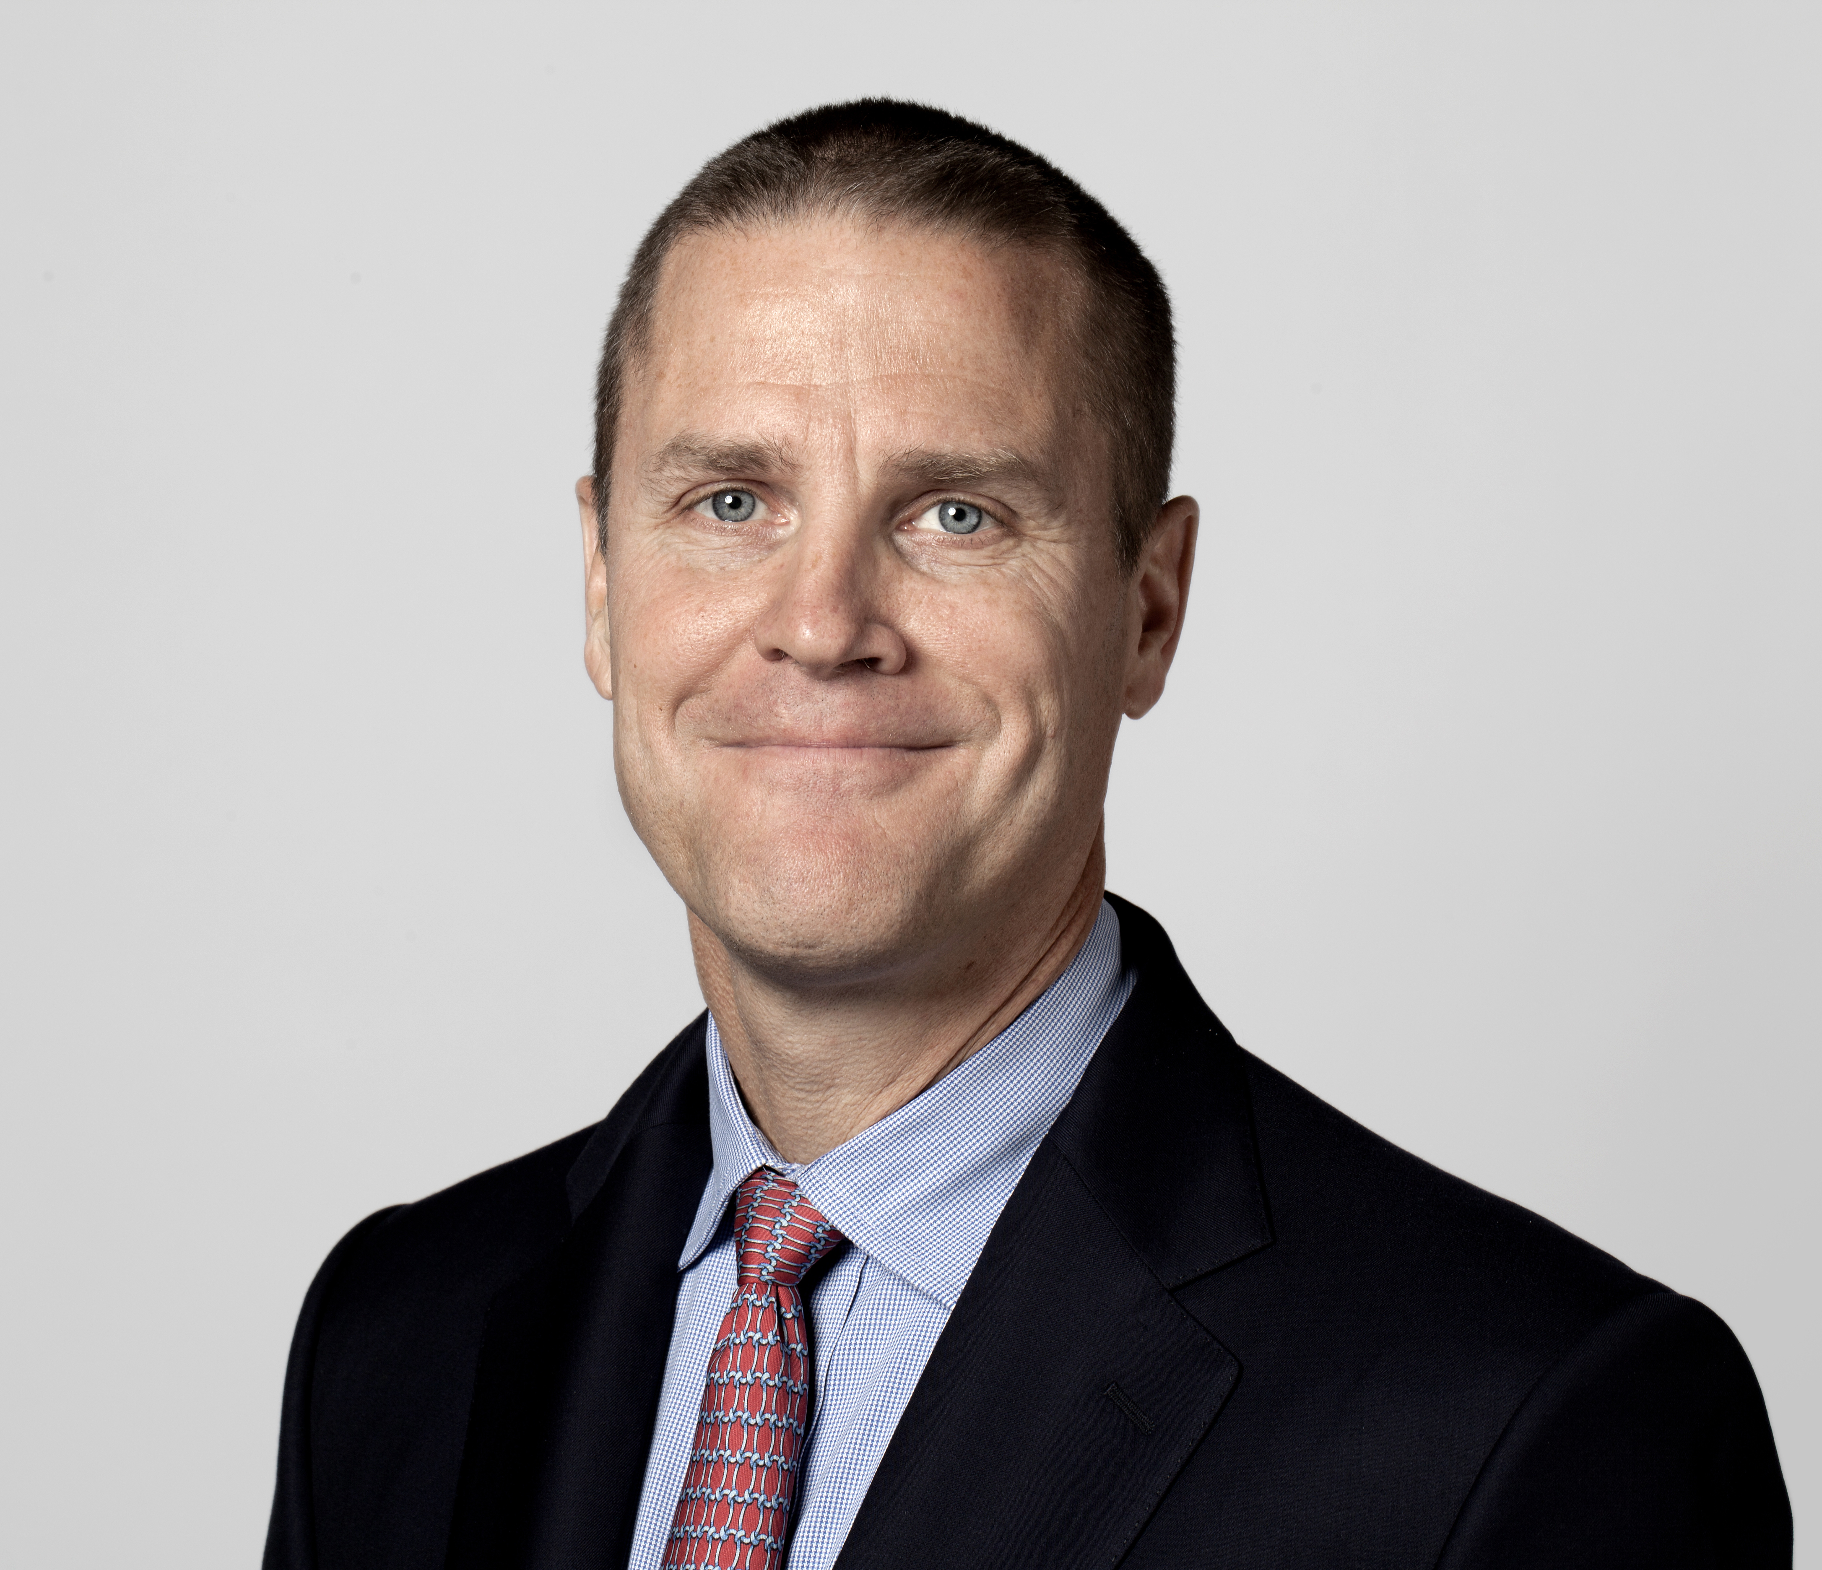
Chris Brown

President, Vestas Americas

Chris Brown is President for Vestas’ sales and service operations in the United States and Canada. Brown also serves on the executive committee as Group Senior Vice President for Vestas Wind Systems, the world’s largest provider of wind turbines.
Brown, an energy industry leader with decades of experience running electric utility and independent power operations, joined Vestas in November 2012.
Prior to Vestas, he served as Chief Operating Officer for the City of Detroit for approximately two years.
A board member and chair-elect of the American Wind Energy Association, Brown’s energy background includes time in the offshore wind industry, senior executive at a large U.S. utility and managing director at an international utility. Previously, he was Founder and Chief Executive Officer of Deepwater Wind LLC, where he created the plan for a 3,000 MW offshore wind company; Executive Vice President for DTE Energy Resources, where he was responsible for DTE’s largest non-utility businesses including Energy Services, Coal Services, Biomass and Methane Resources; Senior Vice President of Singapore Power and Managing Director of Singapore Power International; Director of Asia Operations for Entergy Corporation; and Counsel for Constellation Energy.
Brown holds a Juris Doctor degree from the Villanova University School of Law and a bachelor’s degree in political science from the University of Delaware. He also attended Bonn University in Bonn, Germany, as a Fulbright Scholar, where he studied economics and finance.

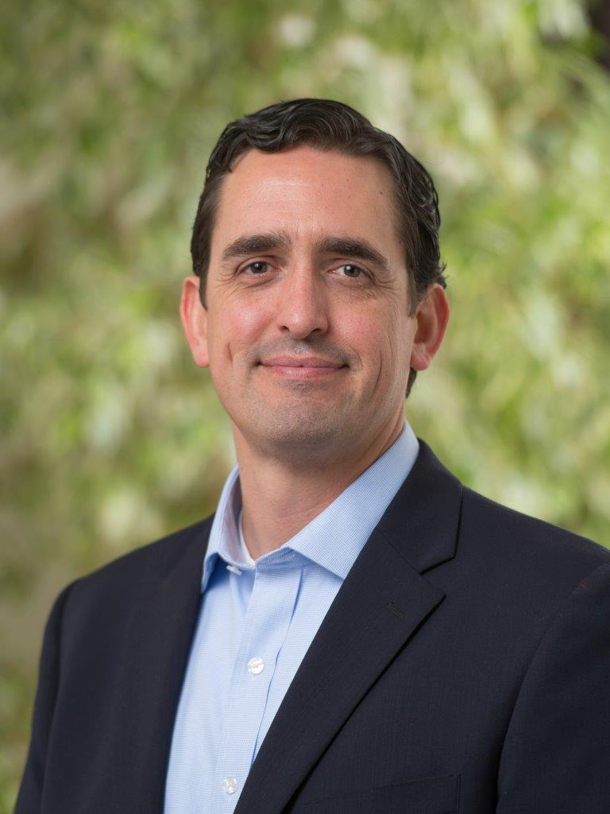
André DeVilbiss

SVP, Strategic Development, Recurrent Energy

André DeVilbiss is the Senior Vice President, Strategic Development at Recurrent Energy, a subsidiary of Canadian Solar. Recurrent Energy is one of North America’s largest solar project developers, delivering clean, competitive electricity to utilities and large energy buyers. André oversees Recurrent Energy’s business strategy, partner development and policy initiatives to drive new growth opportunities for the company. Under André’s direction, Recurrent Energy has expanded into new markets, including the company’s energy storage business line and non-utility energy customer segments.
André has over 15 years of combined experience in finance and energy markets translating entrepreneurial ideas into successful teams and results. During his tenure with Recurrent Energy, André has made several key contributions to the company’s growth including developing more than 750MWp of operational solar projects.
Prior to Recurrent Energy, André was a Vice President at Banc of America Securities LLC (now Bank of America Merrill Lynch) where he advised a wide spectrum of Fortune 500 companies on debt market financings. André holds an MBA from UC Berkeley’s Haas School of Business and a BA in Economics from the University of Chicago.

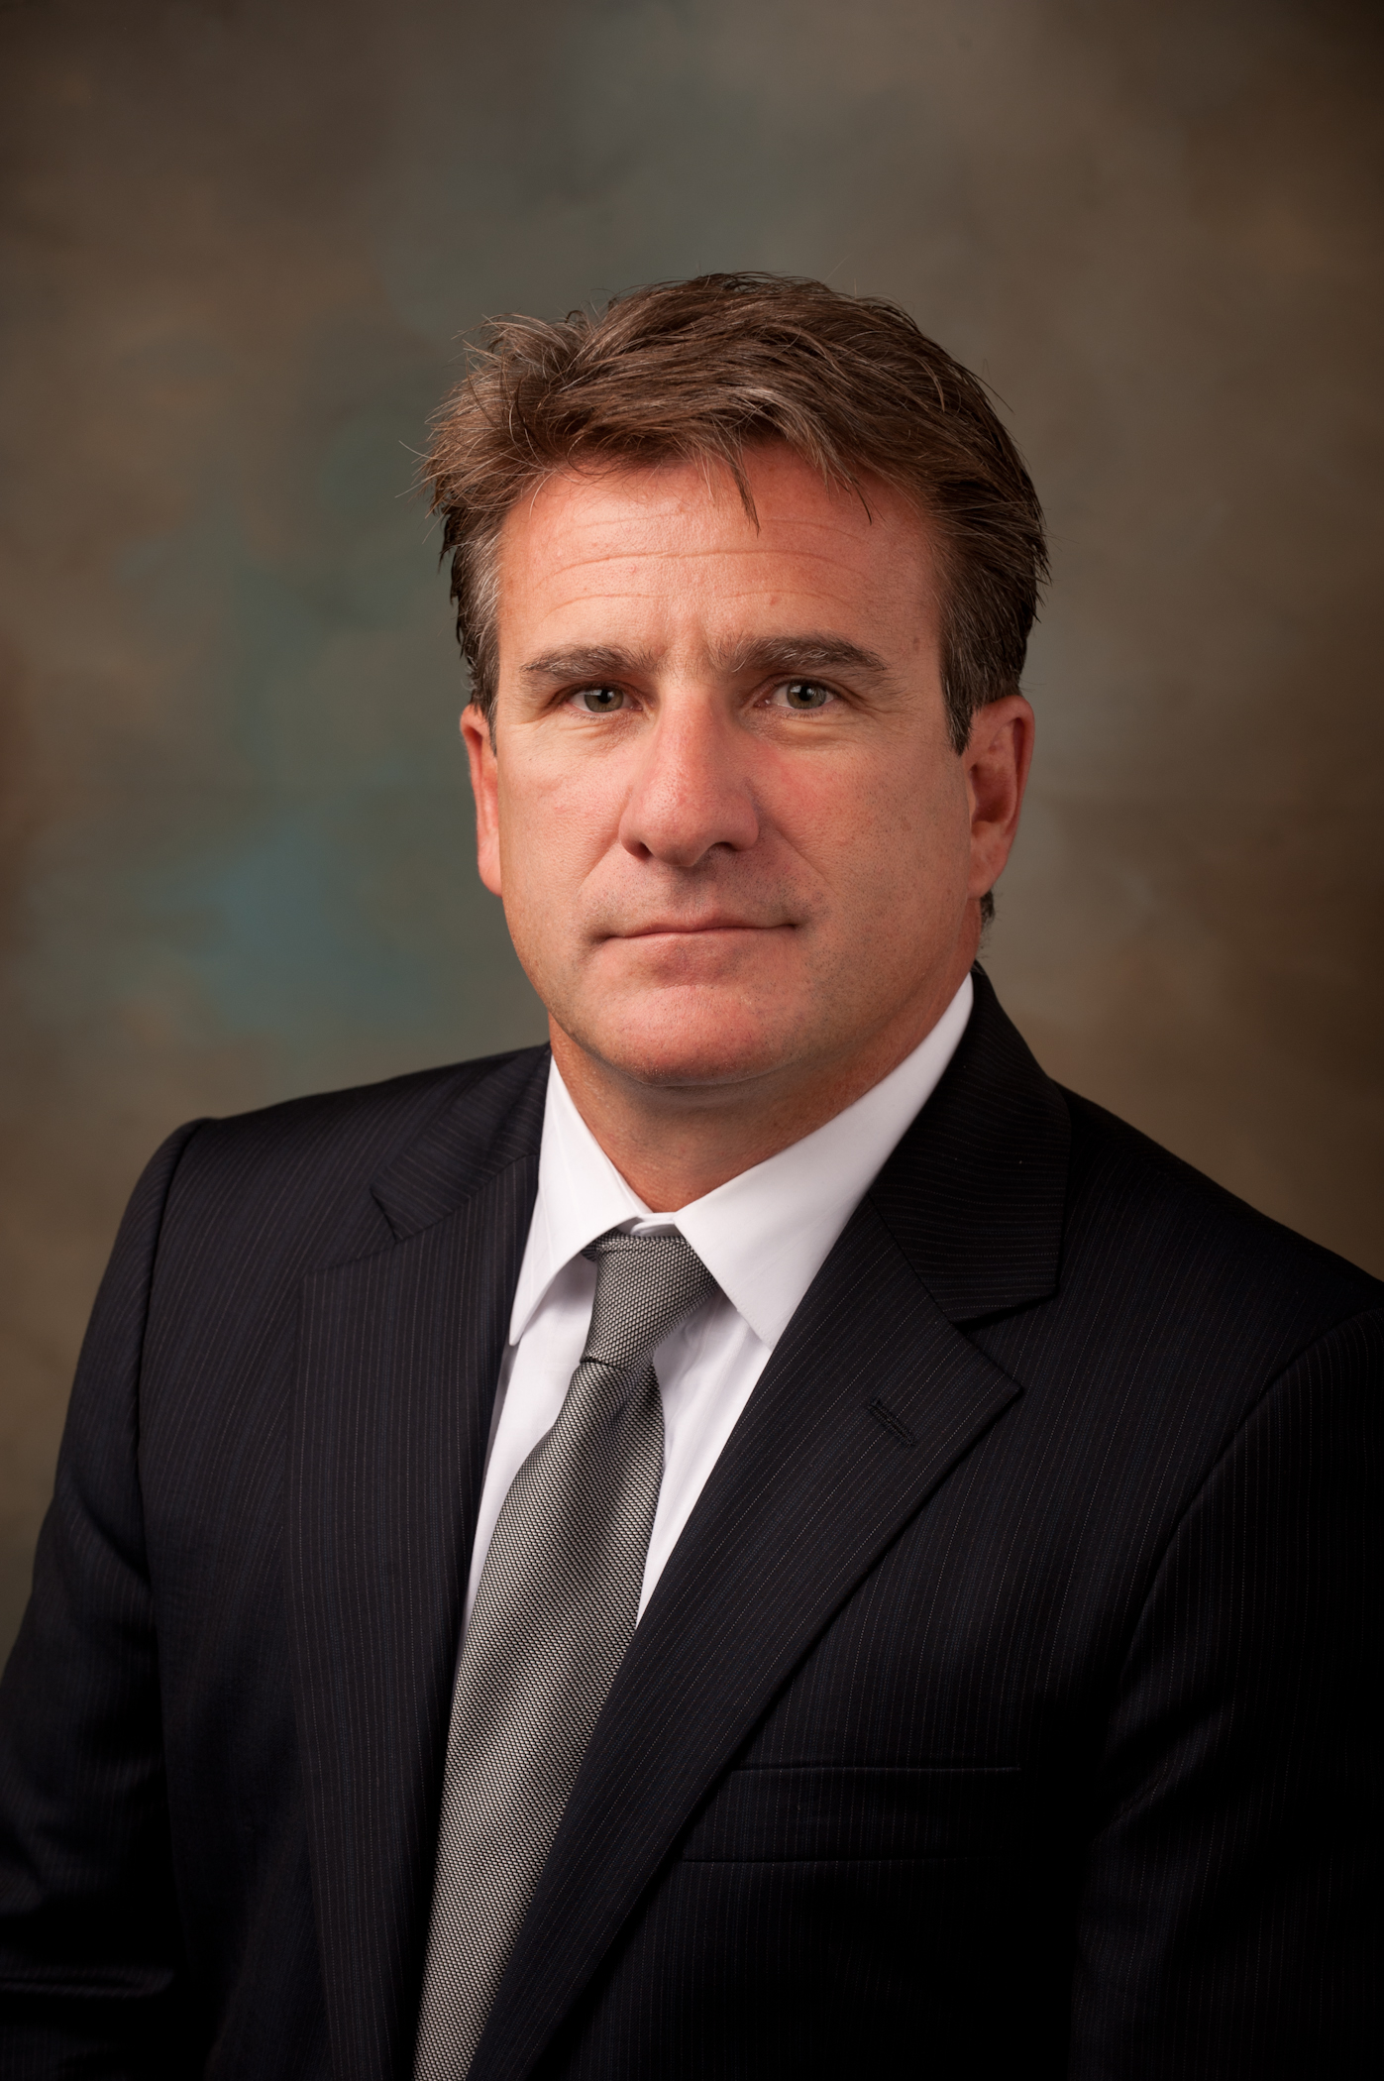
Bill DiCroce

President and COO, Veolia North America’s Municipal and Commercial Business

Bill is now leading Veolia North America’s Municipal and Commercial business, which is the result of a recent merger of Veolia North America’s energy and municipal water/wastewater businesses. He previously served as President and Chief Executive Officer of Veolia Energy North America, a January 2013 appointment, following his successful role as the company’s Executive Vice President and Chief Operating Officer. He joined Veolia Energy North America in June 2008 as Senior Vice President - East Region.
Before joining Veolia, Bill was the President and Chief Operating Officer of NSTAR Electric and Gas Company's unregulated subsidiaries, which owned and operated private utilities (Medical Area Total Energy Plant, Inc.- MATEP), as well as other district energy and telecommunication businesses in the greater Boston area.
Bill began his career with General Electric at the Knolls Atomic Power Laboratory, where he was certified as a nuclear power engineer within the U.S. Naval Nuclear Propulsion program. Bill next entered the commercial nuclear power generation industry and held a succession of operational, managerial and executive positions within Boston Edison and the Entergy Corporation.
Bill earned a bachelor's degree in marine engineering at the Massachusetts Maritime Academy and an M.B.A. at Boston University. At the Massachusetts Maritime Academy, he served on the undergraduate and advanced degree program's Advisory Council and was an adjunct professor for nuclear power technology.

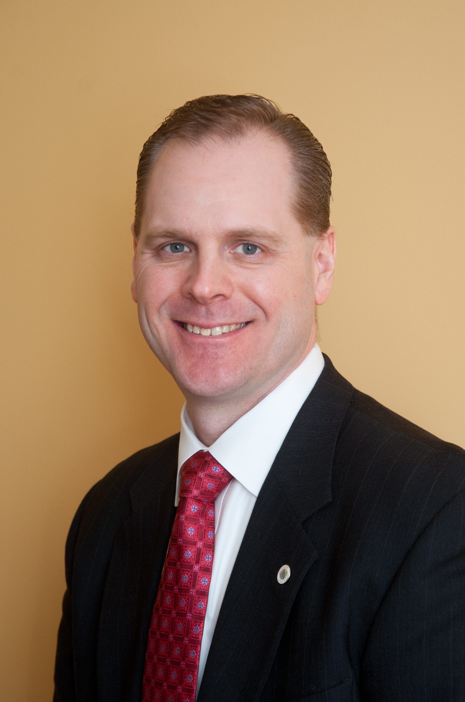
Terrill Laughton

Vice President and General Manager, Integrated Demand Resources, Johnson Controls

Terrill Laughton is the Vice President & General Manager for Johnson Controls’ Integrated Demand Response (iDR) business unit. He and his team are responsible for the overall performance for all markets and direct utility contracts held by JCI for Demand Response. Prior to his current role with the iDR team, Mr. Laughton led the sales and operations group for iDR across all markets. Prior to joining the iDR business unit, Mr. Laughton held several roles within Johnson Controls. Mr. Laughton previously led the development of all Energy Savings Performance Contracts with Federal Government customers for JCI’s Federal Solutions business, developed the acquisition strategy & drove the integration efforts for JCI’s acquisition of the Demand Response Provider EnergyConnect, and directed a team of internal & external consultants that worked on a variety of corporate initiatives across all markets for JCI.
Before joining Johnson Controls, Mr. Laughton was an Associate Principal in the Chicago Office of McKinsey & Company where he was part of the Global Energy and Materials (GEM) practice. Prior to McKinsey & Company, Mr. Laughton worked for Exelon Corporation, one of the largest U.S. utilities. Mr. Laughton holds an M.B.A. from the University of Chicago. He has a MS and BS from the University of Illinois at Urbana-Champaign in nuclear engineering.

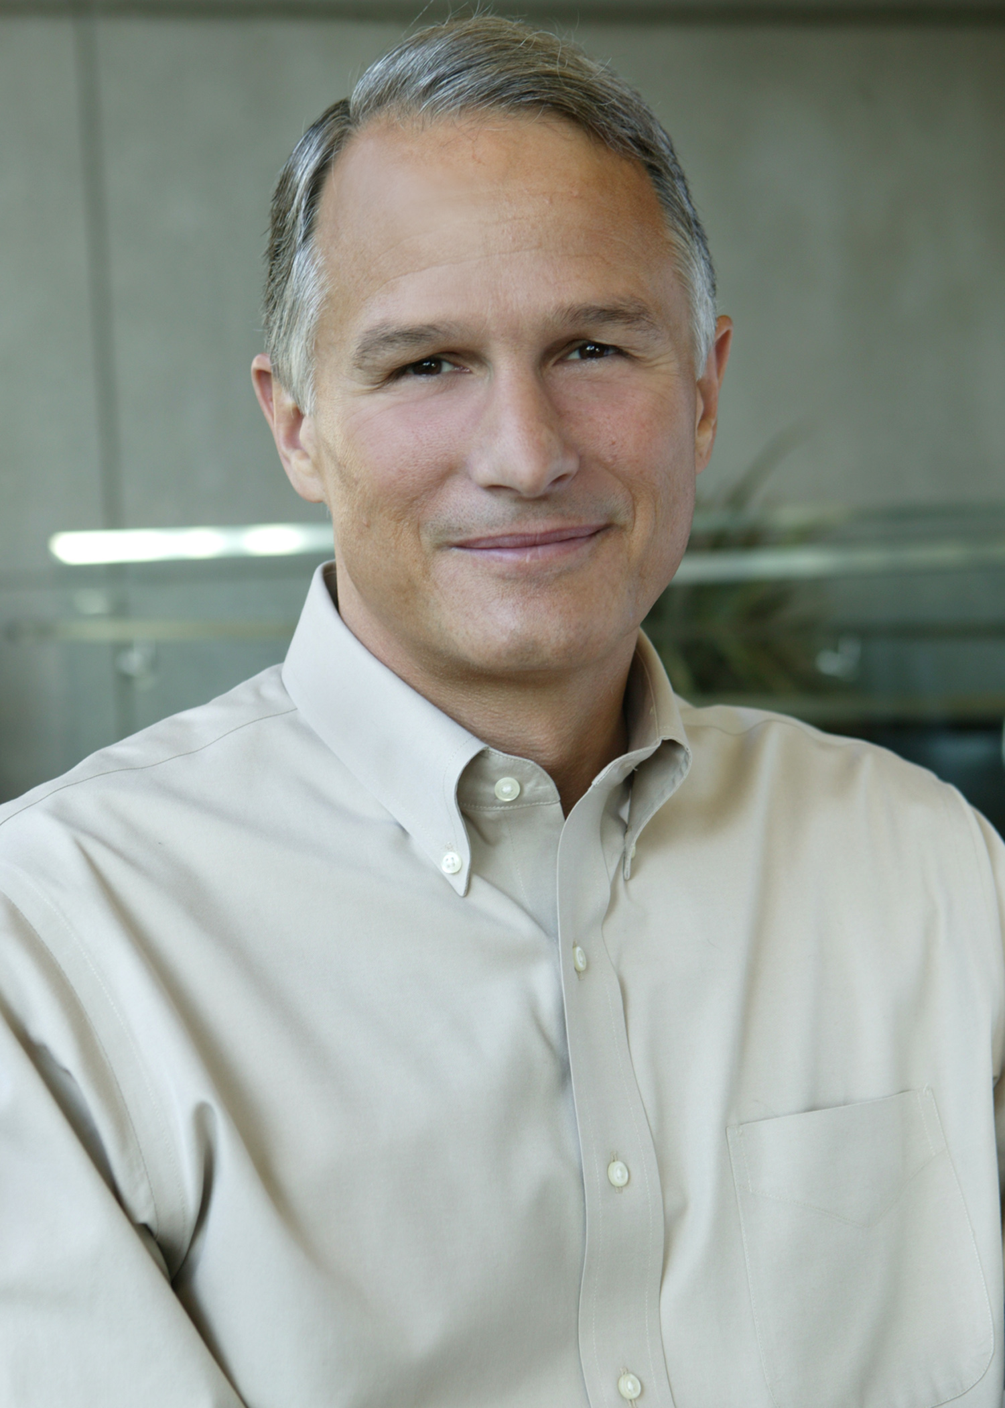
Dan'l Lewin

Corporate Vice President, Technology and Civic Engagement, Microsoft
Dan'l Lewin is a Corporate Vice President at Microsoft, leading the company’s work in technology and civic engagement, including campaign technologies, environmental sustainability, policy-oriented academic outreach and university relations. Previously, he led the company’s global engagement with startups and venture capitalists and business relationships with strategic industry partners. Lewin reports to Microsoft President Brad Smith and also has executive and site responsibility for the company's operations in Silicon Valley.
Lewin has spent more than 30 years as a Silicon Valley-based executive, leading sales and marketing divisions for companies including Apple Computer Inc., NeXT Inc. and GO Corp. Before joining Microsoft in 2001, he was CEO of Aurigin Systems Inc.
Lewin serves on the boards of the Silicon Valley Community Foundation, World Business Chicago, the UC Davis Energy Efficiency Center and the Tech Museum of Innovation. He is also on the Advisory Council for the Department of Politics at Princeton University and on the Advisory Board of UI LABS. Lewin holds an AB in politics from Princeton University.

Mary Rhinehart

Chairman, President & Chief Executive Officer Johns Manville (A Berkshire Hathaway Company)

Mary Rhinehart is Chairman, President and CEO of Johns Manville (JM), a global manufacturer of premium building materials and engineered products. Prior to becoming CEO, Mary was CFO of JM with responsibility for all financial elements of the organization as well as global supply chain. Since joining JM in 1979, she has held leadership roles in international and domestic banking, human resources, global treasury and strategic business development, and has had management and bottom-line responsibility for several of JM’s business units. Mary takes great pride in giving back to the community; she has been pivotal in the growth of JM’s corporate philanthropy program. She also serves on several boards including University of Colorado Health Systems, CoBiz Financial and Ply Gem Industries Inc. Mary is on the Executive Committee for the Policy Advisory Board of the Harvard Joint Center for Housing Studies, a member of the International Women’s Forum, The Colorado Forum, C200, The Leadership Investment, the Boy Scouts of Colorado, and has been honored with several prestigious recognitions, both professionally and as a community leader. Mary is a former Chairman of the Board at Craig Hospital, and a former board member of the Denver Chamber of Commerce, Kempe Children’s Foundation, and the University of Denver’s Daniels College of Business Executive Advisory Board.
A native of Wichita, Kan., Mary earned a B.S. degree in finance cum laude from the University of Colorado at Boulder, and an M.B.A. from the University of Denver.

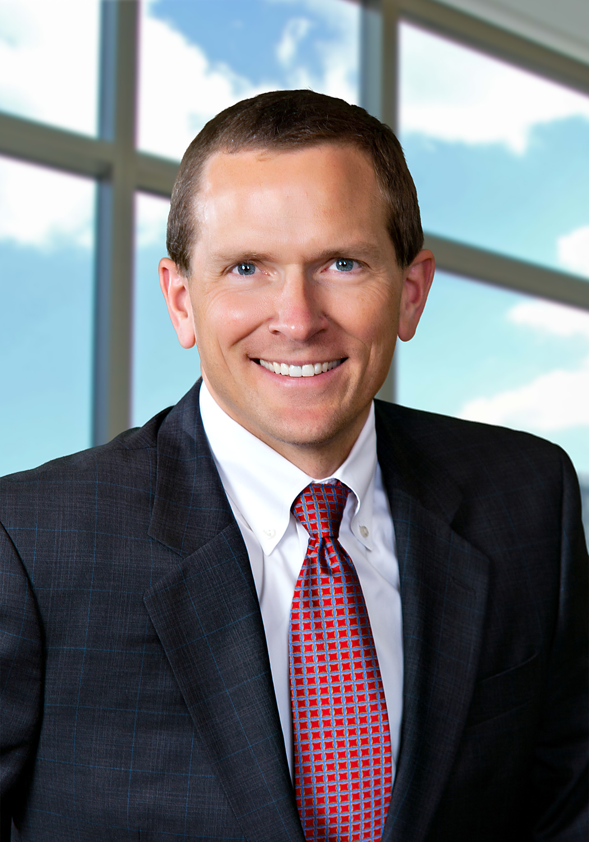
Kevin Self

Senior Vice President, Strategic Business Development and Government Relations, Schneider Electric

As a member of Schneider Electric’s North America Executive Leadership Team, Kevin is responsible for the development and execution of a winning strategy that drives profitable growth across all lines of business in alignment with Schneider Electric’s recently launched Life Is On corporate brand.
Kevin’s responsibilities include leading the overall North America strategy development process; leading the Smart Cities efforts; developing and maximizing government relationships at state and federal levels; and identifying inorganic growth opportunities.
Kevin previously held Strategy & Corporate Development roles with Johnson Controls’ Building Efficiency Business, Miller Brewing Company, GE Healthcare, and McKinsey & Company. Kevin holds an MBA from Northwestern University, and MS and BS degrees in engineering from The University of Michigan.

