Advanced Energy Economy NARUC Draft Manual Reply Comments
Introduction
Advanced Energy Economy (AEE) is a national business association representing leaders in the advanced energy industry. AEE supports a broad portfolio of technologies, products and services that enhance U.S. competitiveness and economic growth through an efficient, high-performing energy system that is clean, secure and affordable. To that end, AEE applauds NARUC for developing a distributed energy resources (DER) compensation manual to assist jurisdictions in navigating the challenges, considerations, and policy developments related to this important topic. AEE is pleased to offer the following comments in response to the July 21, 2016 Draft Manual.

The first draft of the manual provides a solid foundation to build from and we encourage NARUC to make additional improvements to the manual by providing specific examples of alternative rate designs already being implemented or considered in different jurisdictions across the country, more deeply exploring the benefits and costs of DER to include their full range of benefits, presenting a more robust discussion on technologies needed to enable DER, and outlining a broader array of regulatory tools beyond rate design to give regulators a better sense of the full suite of options they have to align utility incentives with the growth of DER.

Our comments are broken down into six sections:

1) Examples of alternative rate design already being implemented or considered
- The examples in this section can be incorporated in Section IV or V of the Manual to give readers concrete examples of good rate design options in action and/or being considered.
2) Determining the benefits and costs of DER
- This section is meant to provide additional depth to the Manual in discussing how to measure and weigh the benefits and costs of DER and could be incorporated in Section IV of the Manual.
3) Expanding on Manual Section VI on “Technology, Services, and the Evolving Marketplace”
- This section discusses how Section VI of the Manual can be augmented with technologies that were not originally included and provide more detail on the ones that were to help readers better understand the role of technology in enabling DER compensation and rate design.
4) Additional tools in the regulator's toolbox (outside of traditional rate design) for addressing rate design concerns
- This section looks at how rate design issues can be addressed not just by rate design solutions, but also by other tools within the regulator’s toolbox, such as integrated distribution system planning and/or ways of aligning utility incentives with the growth of DER. These ideas could be incorporated in Section IV of the Manual or form a new section altogether.
5) Specific comments
- This section makes a handful of other specific suggestions that were not captured elsewhere in our comments.
6) Looking ahead at next steps for the Manual and NARUC
- This section suggests how NARUC can make the Manual a living document, regularly updated as technology and best practices evolve, and also suggests additional steps NARUC can take to further assist the regulatory community on these issues.

- Examples of alternative rate design already being implemented or considered

The Draft Manual contains useful information outlining the various available rate design options (Section II), considerations, questions and challenges (Section IV), and compensation methodologies (Section V). The Manual could benefit from additional context by including brief descriptions of rate designs and rate design approaches that are being considered or implemented across the country, where information and data are available. To this end, AEE sees information sharing across states and jurisdictions, including what has worked and what has not worked, as an invaluable resource. Particularly in Section IV and V, the Manual could provide examples and data-driven analysis. As examples of what NARUC could include in the Manual, we have provided below brief descriptions of case studies, pilots, and recent PUC actions that would give users of the Draft Manual some real world examples.

California Residential Rate Design (R1206013)
Key topics: customer education gap, default TOU, opt-in TOU pilots.
In July 2015, the California PUC (CPUC) ordered the investor owned utilities (IOUs) - Pacific Gas & Electric, San Diego Gas & Electric, and Southern California Edison - to introduce default time-of-use (TOU) rates for residential customers by 2019. In addition to the default TOU rate, customers will be able to choose from a menu of options that will contain a non-TOU rate and other time varying rates. The CPUC directed the IOUs to prepare a menu of at least three opt-in TOU rate design pilots to begin in the summer of 2016 and a default pilot to commence in 2018. At the same time, California is addressing the customer education gap. The CPUC ordered the setting up of two working groups: one to guide the development, deployment and measurement of the pilots and the other to develop and manage the marketing and education of the residential customer base leading up to TOU deployment. On July 22, 2016, an Administrative Law Judge (ALJ) directed the IOUs to submit plans by November 1, 2016, for marketing and educating customers on upcoming rate reform including default TOU. To that end, the California utilities are currently deploying bill comparison tools online that allow customers to model what their bills will look like under the different TOU options based on their historical usage patterns and willingness to make additional usage modifications.

Arizona Time Varying Rates
Key topics: customer adoption of opt-in TOU
Arizona utilities have offered various time varying rate (TVR) options to their customers since the 1980s. As of 2015, Arizona Public Service has enrolled over 52% of its 1.2 million customers in an opt-in TOU rate (the most of any utility in the country) while Salt River Project has enrolled over 30% of its one million customers on an opt-in TOU rate. Arizona Public Service offers segmented TVR plans to suit diverse customer needs including complex rates and shortened peak periods with high price differentials. In addition, the utility uses a “point of sale” strategy to enroll customers when they contact for a new service.

Massachusetts Time Varying Rates (14-04)
Key topics: default TOU, opt-in TVR
In November 2014, the Massachusetts Department of Public Utilities ordered utilities to offer a default TOU rate with a critical peak price (CPP) component (following the implementation of advanced metering functionality); and an option to opt out of the default rate and chose a flat rate with a peak time rebate (PTR) component. In August 2015, utilities filed their initial grid modernization plans (15-120, 15-121, and 15-122), which all included several TVR options.

Illinois Real-Time Pricing
Key topics: RTP bill savings
Commonwealth Edison (ComEd) and Ameren Illinois have offered real-time pricing tariffs to their customers since 2007. ComEd’s Hourly Pricing Program, which currently has 11,000 participating customers, has resulted in average bill savings of 15%, or $15 million in total. Ameren Illinois’ Power Smart Pricing Program, which also has over 10,000 participating customers, has achieved similar results.

New York Value of DER Proceeding (“LMP+D ”)(15-E-0751)
Key topics: net metering, value of DER
The New York Public Service Commission (PSC) is currently engaging stakeholders in a collaborative process to identify new approaches for valuing DER. It is working on both an interim successor to net metering and a long-term full-value of DER methodology, both based on the “LMP+D” approach where LMP represents all wholesale market values and “D” represents all other values, including distribution system benefits and environmental externalities (which are not fully captured in market prices). The goal is to have an interim methodology adopted in 2016 and to complete development of the full-value methodology in 2017.

Rhode Island Investigation Into the Changing Electric Distribution System (4600)
Key topics: distribution system planning
On March 3, 2016, the Commission opened an investigation into modernizing National Grid's rate structure as the result of a changing distribution system. This investigation will help the Commission understand the costs and benefits caused by different activities on the distribution system for use in future proceedings. Specifically this investigation is addressing the following questions through a stakeholder committee: 1) What are the costs and benefits that can be applied across any and/or all programs, identifying each and whether each is aligned with state policy?; 2) At what level should these costs and benefits be quantified—where physically on the system and where in cost-allocation and rates?; and 3) How can we best measure these costs and benefits at these levels–what level of visibility is required on the system and how is that visibility accomplished?

National Grid Smart Energy Solutions Program Worchester, MA
Key topics: TVR bill savings, customer retention rate
This is one of the most comprehensive smart grid pilots underway in the Northeast. The pilot signed up 11,000 customers and saved a total of 2,300 MWh in 2015. The pilot includes two dynamic pricing tariffs: Smart Rewards Pricing and Conservation Day Rebate. The programs notified customers of 20 peak event days where the price of wholesale electricity was expected to spike. During these days, participating customers reduced their energy usage by over 30%. The average residential customer participating in the Smart Rewards Pricing program saved over $100 in the summer of 2015 while the average residential customer on the Conservation Day Rebate program received over $20 in rebates. Combined, both programs saved customers $1.25 million. Additionally, National Grid achieved a 98% retention rate, which demonstrates customer satisfaction in the program.

Kauai Island Utility Cooperative TOU Solar Pilot
Key topics: TOU pilot, in-home real-time energy usage display
On September 21, 2015, the Hawaii Public Utilities Commission gave approval to Kauai Island Utility Cooperative to implement a one-year, 300 person time-of-use solar pilot which will offer a 25 percent discount on electric rates during off-peak daytime hours to shift load to the day when solar is overloading the grid. Participating customers need to have smart meters and will also receive a digital monitor to see real-time usage as well as a $200 payment towards the installation of a water heater timer. The program began in the first quarter of 2016.

Sacramento Municipal Utility District (SMUD) SmartPricing Options Pilot, Sacramento County, CA
Key topics: TOU and TVR pilot, customer retention rate, peak load reductions
During 2012 and 2013, SMUD conducted a SmartPricing Options Pilot for over 8,000 customers. The pilot included three time-based rate programs: a two-period TOU rate with a three-hour on-peak period (4-7 p.m.); a critical peak price (CPP) on a flat underlying rate; and a TOU with a CPP overlay. Overall load reductions from the pilot ranged from 6 to 26% during peak hours. The CPP rates (with a maximum of 12 events per year) saw the highest reductions. Additionally, over the entire pilot period, only 4 to 9% of customers elected to leave the pricing pilot.

Baltimore Gas and Electric (BGE) Smart Energy Rewards, MD
Key topics: default PTR, bill savings, peak load reduction
Baltimore Gas and Electric (BGE) began rolling out their peak time rebate program, Smart Energy Rewards, in 2012, as the default rate for all customers with an installed smart meter. As of 2016, more than one million customers were enrolled and the average bill credit earned during a peak event was $6.67. The program works by notifying customers by phone, email, or text the day before an Energy Savings Day and if the customer reduces their usage from 1 to 7 p.m. the following day they receive a $1.25 per kWh bill credit. Over the first two years of the program it saved consumers in BGE’s capacity zone $162 million in capacity charges and $7 million in avoided transmission and distribution infrastructure costs (these are reduced system costs that accrue to all BGE customers and not just participating customers). Non-BGE customers in adjacent zones saved an additional $126 million due to the program, illustrating how benefits extend to the system at large, including non-participants.

Green Mountain Power eEnergy Vermont Smart Grid Project, Rutland, VT
Key topics: TVR peak load reductions
During the fall of 2012 and summer of 2013, Green Mountain Power (GMP) conducted a consumer behavior study to compare the results of two different electricity-pricing structures: CPP and critical peak rebate (CPR). The project, which included over 18,000 customers, resulted in the average CPP customer reducing their energy usage by 5.3-15% during peak events and the average CPR customer reducing their energy usage by 3.8-8.1% during peak events.

Oklahoma Gas and Electric Smart Hours, OK
Key topics: TVR bill savings, peak demand reductions, customer adoption of TVR
Oklahoma Gas & Electric has an opt-in TOU program with variable peak pricing (VPP) called Smart Hours with 120,000 customers enrolled as of 2015. The program has a goal of enrolling over 20 percent of their residential customers, with the final objective of delaying the building of a fossil-fuel generation plant. The program offers a non-peak rate and a high variable rate during peak demand from 2 p.m. to 7 p.m. Average savings are $150-200 per year, with peak demand reductions of 1.26 kW per customer. Customers with smart thermostats, a voluntary element of being on the program, reduced their peak by 1.65 kW on average.Through 2015, the program has cut the utility’s peak by 150 MW or about 2%.

- Determining the benefits and costs of DER

AEE generally agrees with the tone of the Draft Manual and appreciates the recognition that much work is still left to be done to accurately measure and weigh the benefits and costs of DER. That said, there are parts of the Manual that incorrectly jump to conclusions stating that the costs outweigh the benefits, such as on page 35 where the Manual characterizes net metering as “clearly a subsidy.” To ensure that the Manual fairly portrays DER, AEE strongly recommends that the Manual go into more detail on the full range of benefits that DER can provide. Furthermore, DER encompasses a variety of technologies, and the benefits and costs of each are not the same. Therefore, while it is appropriate to discuss DER as a group at times, it is also necessary to consider benefits and costs with a suitable level of granularity.

As we noted in our original comments, “DER is currently not accurately valued/compensated for what it can provide to the grid, including capacity, transmission and distribution (T&D) cost avoidance/deferral and ancillary services such as volt/VAR support. Valuation should also consider the benefits beyond grid impacts. We favor use of a comprehensive benefit-cost analysis.” We recommend that the Manual go into more detail on the benefits and costs of DER and suggest a possible benefit cost analysis framework to provide a common methodology for regulators to use when considering the costs and benefits of new projects and investments. While the specific value of DER benefits and costs will be different for each state and/or jurisdiction, a recommended methodology or planning process used to calculate these values could be beneficial to regulators.

The benefit-cost analysis techniques that have been used for many years for evaluating resources (mainly energy efficiency programs and measures) are undergoing change. The current screening processes in many states are too narrowly defined, ignore some of the harder-to-quantify costs and benefits, and do not necessarily account for the benefits articulated in state energy policy goals. In September 2014, Synapse Energy Economics prepared a report for the Advanced Energy Economy Institute (AEEI), titled Benefit-Cost Analysis for Distributed Energy Resources: A Framework for Accounting for All Relevant Costs and Benefits. In this report, AEEI proposed a benefit cost analysis framework for New York, however much of the report is broadly applicable to other states.

AEE supports the Societal Cost Test as the principal test for deciding whether to proceed with any particular DER program or portfolio. The Societal Cost Test is the most comprehensive of the five common screening tests (the Participant Cost Test, the Utility Cost Test, the Total Resource Cost Test, the Societal Cost Test, and the Ratepayer Impact Measure Test), and provides the most information about the impacts of DER. Furthermore, we recommend use of the Utility Cost Test, and not the Rate Impact Measure Test, to inform the analyses of rate, bill, and participant impacts. The Utility Cost Test provides a good indication of the extent to which utility system costs, and therefore average customer bills, are likely to be reduced as a result of DER investments. However, the Utility Cost Test results should not be used as the primary basis for deciding whether to proceed with any particular DER program or portfolio, because they do not include the impacts associated with key energy policy goals or benefits that accrue to the customer that are extended to the utility.

Below is an overview of all costs and benefits that should be taken into account:

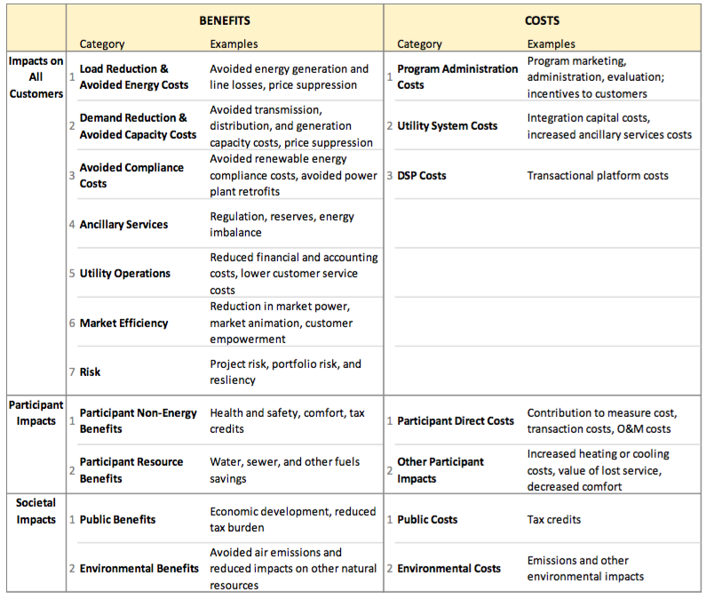

It is also important to note the interactive benefits of DER resources. For some DER technologies, the net benefits may increase when certain technologies are used together. For example, co-location of distributed solar and flexible storage could create combined benefits that exceed the benefits of either technology individually. Other technology combinations include small wind with solar, anaerobic digester gas with fuel cells and demand response (DR) technologies with energy storage. Another, example would be the effect of home energy report (HER) programs in increasing customer participation in other DER programs and technologies.

Integrated demand-side management (IDSM) programs offer another example of interactive benefits. IDSM programs integrate energy efficiency measures with DR technologies by providing intelligent control systems that reduce energy consumption and demand. When effectively combined as part of a comprehensive energy saving retrofit project, these systems also provide a cost-effective DR option to help with system peaks and customer engagement.

Many DER impacts, such as avoided energy costs, have already been quantified and monetized by regulators and utilities. Such impacts can be immediately incorporated into cost-benefit analyses and improved over time as new information or techniques become available. Other DER impacts have not yet been addressed or monetized. For some of these impacts, developing monetary values may currently be infeasible or impractical. Data may be unavailable, studies may require a considerable amount of time and resources to implement, and the results of such studies may still result in a high degree of uncertainty. Despite these challenges, DER impacts should not be excluded or ignored on the grounds that they are difficult to quantify or monetize. Approximating hard-to-quantify impacts is preferable to assuming that those costs and benefits do not exist or have no value.

Alternative approaches to estimating DER impacts include:

1. Proxies
2. Alternative benchmarks
3. Regulatory judgment
4. Multi-attribute decision analysis

- Section VI (Tech, Services & the Evolving Marketplace)

AEE believes this section is crucial, as the adoption of relevant technology is foundational for deployment of DERs and the creation of programs, products, services and rates that will ultimately transform how customers, utilities, and third party service providers interact with the modern grid. To show the clear connection between this section and the topic of the Manual, we recommend that the section be renamed as “Relevant Technologies and Services for DER Tariffs”.

We want this section to provide the reader with a robust technology overview and therefore believe it is necessary to add some technologies that were not originally included, provide more detail on the ones that were, and correct any incorrect representations. This is provided in the appendix.

In the context of designing rates for DER, we define advanced technologies to be hardware and software that enable remote measurement, monitoring and/or control of energy consumption and distributed resources for the benefit of consumers, energy services companies, and utilities.

We have defined technologies and services involved in DER rate development contextually and they are listed in the appendix. Additionally, we have provided two visuals on infrastructure architecture and key data paths between the smart meter and utility system back-end to illustrate the same.

We have added relevant technologies and services that have not been included in the Manual such as Meter Data Management, Customer Analytics, Automation etc. as well as market requirements such as Data Access.

With regard to Distributed Energy Management Systems (DERMS) and Advanced Distribution Management System (ADMS) -- while the two technologies are complimentary and can appear to have overlapping functionalities, they are not interchangeable as indicated in the Manual as they perform very distinct core functions.

Increased Hosting Capacity is a benefit derived from a suite of diverse technologies that utilities have at their disposal to manage and control the distribution network with increasing penetration of DERs. It should be classified thus and not as a “technology” as listed in the Manual.

- Additional tools in the regulator's' toolbox

The Draft Manual discussed some of the economic pressures faced by utilities and non-DER customers within a rate class, such as revenue erosion, cost recovery, and cost-shifting (note: AEE believes this should be called revenue shifting, not necessarily cost-shifting). The Manual also discussed several rate design options to address these issues. However, the Draft Manual did not go into detail on all of the tools in the regulator’s toolbox to address these issues. AEE believes the Manual should discuss both aligning utility incentives and integrated distribution system planning to give regulators a better sense of the full suite of options they have to address these economic pressures and how these options interact with rate design.

Aligning Utility Incentives
One of the key areas that can be included in the Manual is aligning utility incentives with DER adoption. Rate design changes may not be fully effective if regulators do not address underlying utility business model issues that deter utilities from looking at all of the options available to them for serving customers and meeting system needs under the traditional cost-of-service regulatory model.

Increasing customer adoption of DERs will challenge traditional utility revenue models, and going forward, utilities will not only need to be indifferent to these market changes from a revenue perspective, but will need to build technology advancements into their business models. One way to do this is through performance metrics. AEE strongly supports the concept of performance metrics and regulatory policies that reward the utility for desired outcomes as opposed to inputs (i.e., capital expenditure). Forward looking, outcomes-based regulation is a natural extension that works well with the existing cost-of-service model and can be implemented relatively quickly to begin to move the utility in the direction of becoming a more innovative, customer-focused company.

We recommend that performance metrics serve as motivating instruments for utility action related to system-wide efficiency (e.g. peak load reduction), DER adoption, customer engagement, access to data, DER interconnection, and energy efficiency. We suggest that these metrics generally be bidirectional, but could be positive only or negative only, depending on the metric, so that the utility has an incentive to always improve performance.

Another way to align utility incentives and maximize the use of existing utility infrastructure is to allow utilities to earn the same return on procured services as on capital investments, a concept more simply defined as infrastructure as a service. Traditionally, utilities earn a return on equity on their capital expenditures (e.g. traditional T&D wires investments), whereas operating expenditures (e.g., software services, contracted DER solutions) are simply passed through to customers. Utilities are therefore incentivized to drive up their capital investments and drive down their operating expenditures between rate cases, which can distort utility investment decisions.

An example of this alternative ratemaking concept is Commissioner Michael Florio's regulatory incentive proposal, which he introduced on April 4, 2016 in California’s Integrated Distributed Energy Resources proceeding (R1410003). The proposal is intended as a pilot program to test the effect of incentives on utility sourcing of services from DER and addresses the conflict between the Commission's policy objectives and the utilities' financial objectives.

Specifically, the pilot would offer a shareholder incentive (equal to the difference between the utilities' return on equity and cost of capital) for the deployment of cost-effective DER that displaces or defers a utility expenditure (either capital or operating if the cost of the proposed DER solution plus the shareholder incentive is the cheaper option).

Another option to consider is adopting the concept of a distributed system operator (DSO), which New York is doing in their Reforming the Energy Vision proceeding (14-M-0101). In New York they are adopting ratemaking changes to enable the growth of the retail market and to create a modern regulatory model that aligns utility revenue models with consumer interests and policy objectives. The new system will allow utilities to create shareholder value by integrating third-party solutions such as DERs that reduce system costs and improve the efficiency, flexibility, and resiliency of the grid. Utilities will still be allowed to earn returns through traditional cost-of-service regulation, but also through a combination of outcome-based performance incentives (“Earning Adjustment Mechanisms” or EAMs) and revenues earned from facilitating consumer driven markets based on their operation of the Distributed System Platform (so-called “Platform Service Revenues”). The goal is to enable market activity and assist in building a robust retail market.

Distribution System Planning
If done well, integrated distribution system planning can allow a state to proactively build a system that can integrate increasing levels of DER, properly value and compensate DER, and provide access to information that leads to DER deployment in high-value areas. This can allow utilities to see DERs as an asset that they actively want to promote. Having utilities consider DER in competition with traditional investments can lead to a more flexible, reliable, resilient, and clean grid, all while saving money for customers.

In order to reach this end, AEE supports meaningful, broad stakeholder engagement and greater transparency in utility distribution system planning and operations. This is needed to ensure that DERs are fully considered on an equal footing, using a transparent process, to traditional utility “poles and wires” investments and to help the utility identify cost-saving DER solutions. Further, the broad stakeholder engagement should extend beyond the planning phase to also continue during and after implementation to appropriately track the benefits and costs of DER investments.

In order to determine where DER deployment would be beneficial, regulators should establish guidelines for measuring the net benefits of DER deployment, including system benefits at the wholesale and distribution levels, customer benefits, and external benefits, including environmental and health impacts. The utility should be directed to update distribution planning processes to support the deployment of DER solutions wherever they provide net benefits using a comprehensive cost benefit analysis framework.

We also support well-designed demonstration projects that test not just new technologies, but also new business model concepts and new types of transactions for distribution-level services. The demonstration projects should have active participation from third parties. We support timely recovery of utility costs associated with the demonstration projects that are pre-approved by regulators regardless of the outcome. The design of the demonstration projects should be based upon pre-defined criteria. For example, one criterion of the project could be whether traditional investments can be deferred or avoided with non-wires DER alternatives.

As part of the planning process, sufficient data must be made available to allow third parties to propose alternatives to traditional utility solutions for meeting grid needs. For example, utility procurements that are overly prescriptive based on assumed solutions may limit competition and deliver less value. Third parties can actively participate in devising cost effective solutions, but only when sufficient system data is made available.

- Specific Comments

This section makes a handful of additional specific suggestions that have not been captured elsewhere in our comments.

On page 15, the Draft Manual stated, “there is no single definition for a Distributed Energy Resource.” AEE believes that NARUC should more explicitly define DER or at least make a more distinct recommendation for what to consider when defining DER. AEE defines DER as resources connected to the distribution system, including distributed generation of all types (combined heat and power, photovoltaics, small wind, fuel cells, etc.), energy storage, electric vehicles, demand response, energy efficiency, and microgrids. As such, it includes options for generating electricity, but also for managing how much and when electricity is used.

On page 20, the Draft Manual stated, “a regulator will need to determine whether or not it is appropriate to include EE in its consideration of DER.” AEE believes that technologies and services on the demand-side, which reduce load, such as EE and DR, are core components of the definition of DER and should always be included.

On page 41, the Draft Manual stated, “regulators are often tasked with two, potentially competing goals: ensuring the financial health and viability of the regulated electric utility and developing policies, rates, and compensation methodologies for DER.” AEE believes that this narrow view of DER implies that DER imposes net costs on the system that utilities cannot recover. We respectfully disagree with this conclusion and suggest that developing appropriate policies, rates and compensation methodologies for DER can provide net benefits, and when coupled with other changes that align utility financial incentives with the interests of consumers, and public policy goals there can be “win-win” outcomes. This can include incremental changes such as revenue decoupling, to more innovative regulatory reforms such as outcomes-based regulation.

On page 56, the Draft Manual stated, “It would never be the case that any single DER would rise to merit attention in a list of important contingencies for an electric system.” AEE believes this is a fairly pessimistic assessment of DERs. Instead this should be reframed by saying that one of the advantages of grid-connected DERs is that, due to their relative size, any single DER asset could never cause a contingency. DERs, when relied on as a portfolio, are low risk, and in aggregate they more than meet the reliability and low risk requirements that are needed to be counted on as a planning contingency.

- Looking ahead at next steps for the Manual and NARUC

Given the rapid pace of technological change and the continued emergence of best practices around rate design and DER compensation, AEE recommends that NARUC outline a process by which this document is kept up-to-date and relevant. To this end, AEE believes the Manual should become a living document that is updated on regular intervals with proper stakeholder input.
Furthermore, in compiling this Manual, NARUC has received input from a wide variety of groups that have put forward different perspectives, materials and information that could be a valuable additional resource for regulators to use when considering rate design options. AEE believes it would be beneficial to make available to the public not only the rate design Manual but also those submitted comments.
As follow-on to the subject matter of this document, AEE also recommends that NARUC evaluate two other potential subjects for development in a similar vein:
- A “how-to” guide on evaluating DER deployment and tariff development
  - Such a guide could for example include lists of “questions to consider” (e.g. 10 questions per topic) that regulators should be looking at or asking their stakeholders when they are evaluating different rate designs options.
- Evolving marketplaces and utility business models
Conclusion
In conclusion, AEE applauds NARUC for undertaking development of this Manual as a valuable resource for regulators and allowing stakeholders an opportunity to comment. DERs are resources that when valued properly and strategically integrated into the grid can benefit both utilities and consumers and help to make the electric grid more flexible, resilient, secure, clean, and affordable. AEE looks forward to continued engagement with NARUC and other stakeholders on this important topic.

APPENDIX: Relevant Technologies and Services for DER Tariffs

FOUNDATIONAL TECHNOLOGY FOR IMPLEMENTING DER TARIFFS

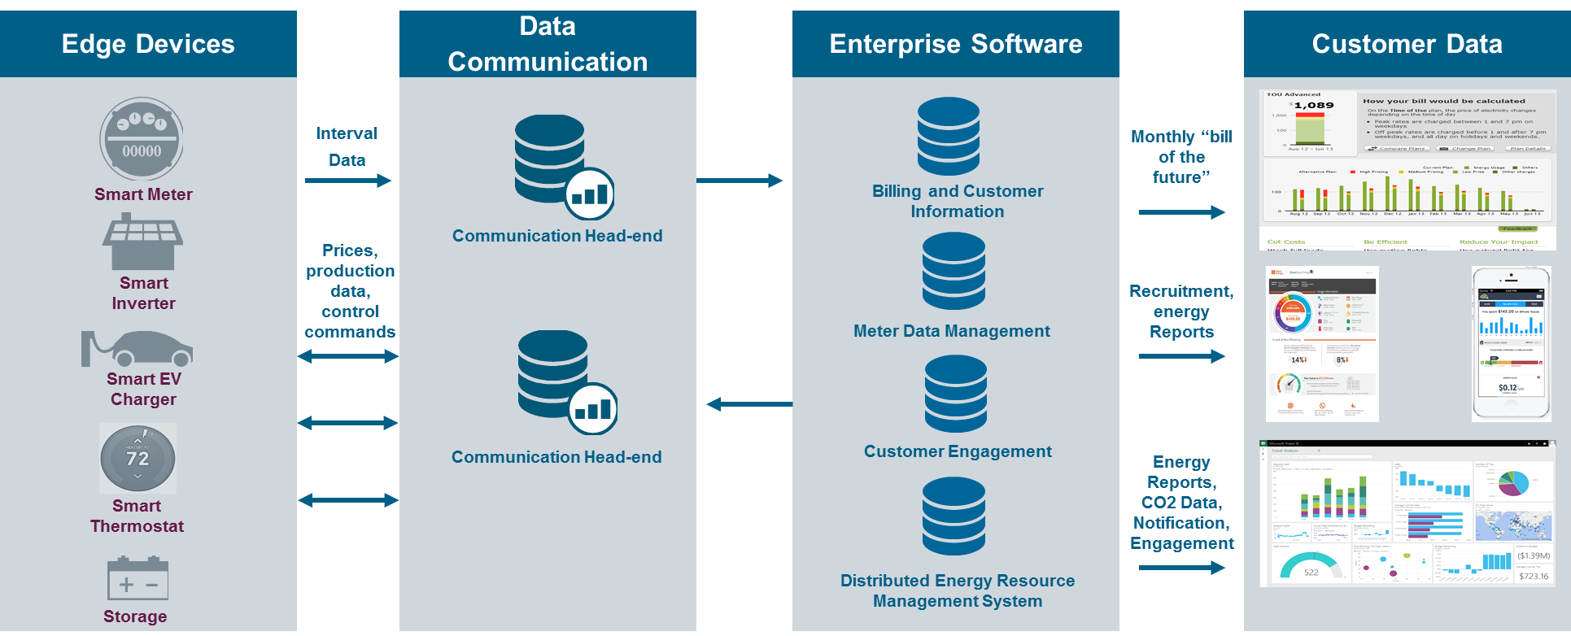

KEY METER DATA PATHS

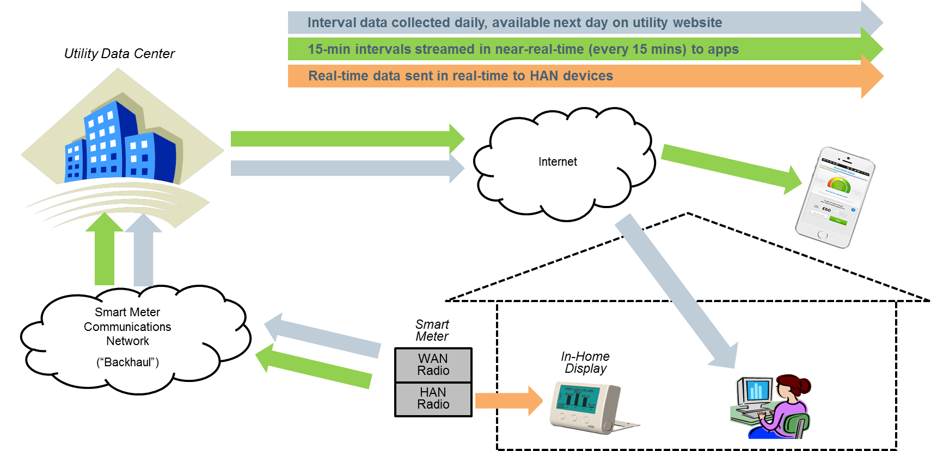

- Advanced Metering Infrastructure (AMI): refers to the entire measurement, collection, and control system for consumption data, including customer meters, communication networks and data management software and often with the capability to manage other distributed devices such as streetlights.

- Advanced Meters or smart meters: electronic meters with two-way communications capabilities that measure consumption of electricity at least hourly, are capable of remote disconnection, provide outage alerts, and record voltage. Smart meters have the capability of providing data as often as every five minutes over a communications network to a central data center. By collecting interval data, smart meters enable time-varying rates and demand charges.

AMI data collection involves the collection and retrieval of meter data typically using a fixed network, which is either a private or public communication infrastructure, which allows the utility to communicate with meters without visiting or driving by the meter location. Examples of such networks include mesh Radio Frequency (RF) networks and public cellular networks.

- Meter Data Management (MDM): software that collects, validates, completes (by inserting estimates for missing data), stores, and delivers to the billing system bill-ready metering data. It provides utilities a place to store the vast amount of meter data collected from the field. To illustrate, hourly interval data results in 8,760 meter readings per meter year, compared to 12 each year for a meter that is read once per month.
An MDM can also be configured to meet the specific requirements of utility applications i.e., meter data can be provided in the same manner to all applications, or it can provide data in the exact form that each application requires. An MDM can also process and store outage and voltage data, as well as enable remote service disconnection. Finally, MDMs provide functionality to support the business processes related to collecting and managing meter data, including tracking meter device configurations and monitoring communications status.

- Customer Analytics: A growing number of software platforms and applications are available to help translate energy meter data into information that energy consumers can use. Customer analytics tools range from enterprise software-as-a-service (SaaS) platforms down to smartphone-based apps, and may rely on sophisticated data analytics and predictive algorithms to help consumers understand ways to use energy more efficiently. For the utility and energy service providers, this same family of analytics add personalization to customer communications and can reduce operating costs associated with providing customer service.

- Customer Education: Provision of consumption and pricing information to end-use customers is key for successful deployment of DER rates. Customers can get access to the information via a utility hosted website or a portal that allows customers to obtain their energy usage data, receive information and recommendations for DER products or services, view bill comparisons of rates for which they qualify, and receive analyses of energy usage on a comparative basis along with recommendations for energy savings and energy management. Such information can also be made available via Apps on smart phones which carry the additional advantage of being able to provide customers with real-time information and notifications on pricing and usage, for example on dynamic pricing programs.

Another key end-use educative technology is energy disaggregation, which enables the measurement of how much energy goes into each major appliance to eliminate inefficiencies. Current available technology in this space can itemize a consumer’s energy bill, analyze energy use and cost for each household appliance enabling
a customer to receive personalized and prioritized savings recommendations.

- Automated Response: These technologies allow customers to reduce or shift load automatically in response to price signals or other inputs. Smart thermostats are a key load-controlling technology that enables customers to automate load reductions and load shifting; smart appliances and building automation systems are other examples. Thermostats and appliances are defined as “smart” when they have the capability of remote management via two-way communications with Internet connectivity.

- Data Access: Fundamental to optimum DER deployment and utilization is secure, synchronous access to comprehensive, accurate and clear energy usage and billing data. Successful growth of DER technologies and provision of new products and services requires adoption of universal data sharing platforms and standardization in the implementation of data access across states. Green Button Connect is currently the most widely developed and accepted standard for accessing customer data – by customers or third parties authorized by customers.

We recommend six guiding principles for data access:

      - Full Data Set: Standardize availability of a requisite set of data for historical and ongoing data access. (We have a specific list we can provide).
      - Synchronous Data: Once a data request is authorized and authenticated, data is delivered on-demand, upon authorization, (e.g. data begins streaming within 90 seconds of request).
      - Instant, Digital Authorization: A digital signature (including click-through) is valid for authorizing data sharing.
      - Instant, Consumer-Centric Authentication: A third-party will not be held to a higher authentication standard than the utility holds itself. Accordingly, the utility will authenticate using consumer-centric login credentials, for example, zip code and account number or online account username and password.
      - Seamless Click-through: A utility account holder will be allowed to begin and end the click-through process on the third-party website. This may happen without any requirement to log in to any other site/process during this flow (e.g. checkbox) or may allow the user to remain in the third-party website flow, even in various authentication scenarios (login, signup, forgotten password, etc.), as in the case of OAuth or open authorization protocols. The click-through process shall be designed to be one-click and the third party may lead the customer request for the types of data and the time frame of data sharing. The customer may approve or reject such a request at its sole discretion.
      - Strong Security Protocols: Adopt strong security protocols. Data security may accommodate cloud-based systems. (We have a specific list of security elements to consider that we can provide).

- Distributed Energy Management Systems (DERMS) and Advanced Distribution Management System (ADMS): While the two technologies are complimentary and can appear to have overlapping functionalities; they are not interchangeable as they perform very distinct core functions.

DERMS software is focused on operation of distributed resources. It enhances utilities’ visibility into DERs and enables utilities to effectively monitor and control – with the customer’s permission – the disparate resources including distributed generation, storage, electric vehicles, and other DR assets to maintain grid reliability and optimize grid efficiency. The platform enables communication between every individual DER and other assets in the field with back office systems through standard communication protocols. Key functionalities include peak reduction, load shifting, voltage optimization, and load forecasting

ADMS software is focused on operation of the grid. It allows utilities to manage distribution networks through capabilities that monitor, control and optimize the secure operation of the network during normal and storm operations (for outage-related restoration activities). It also allows for management of network loading at peak times, and also to optimize the network for improved asset utilization and overall network efficiency and reliability.

- Distribution Planning Software: This software automates the planning of distribution system investments. It includes the ability to determine the grid’s hosting capacity for DERs, which is defined as the capacity to add DERs without affecting the safety or reliability of the grid and without requiring additional investment in grid hardware.

- DER Services : Due to the complexities of integrating DERs into the grid, some technology systems require consulting services to facilitate business process reengineering and technical integration across systems. Services include, for example, training for personnel on new approaches and processes, information technology consulting, as well as general management consulting to design and oversee projects.

Examples will need to be updated over time as technologies and the market evolve. See comments section 6.
http://www.cpuc.ca.gov/uploadedFiles/CPUC_Public_Website/Content/Meetings_and_Events/ResidentialRateReformFactSheet.pdf
http://www.usatoday.com/story/money/2015/05/26/arizona-california-time-of-use-electricity/27985581/
http://web1.env.state.ma.us/DPU/FileRoom//dockets/get/?number=14-04&edit=false
https://hourlypricing.comed.com/
http://midwestenergynews.com/2016/05/04/in-illinois-real-time-pricing-saving-utility-customers-millions/
https://www.powersmartpricing.org/
http://www.citizensutilityboard.org/ciLiveWire_RI_Ameren_PowerSmart.html
http://www.ripuc.org/eventsactions/docket/4600page.html
https://www9.nationalgridus.com/aboutus/a3-1_news2.asp?document=10213
http://www.utilitydive.com/news/hawaii-puc-approves-solar-tou-rate-pilot-for-co-op-kiuc/406249/
https://www.smartgrid.gov/files/SMUD_SmartPricingOptionPilotEvaluationFinalCombo11_5_2014.pdf
https://www.silverspringnet.com/wp-content/uploads/BGE-2016-SGCC-Customer-Engagement-Case-Study-3-10-16.pdf
http://webapp.psc.state.md.us/Intranet/Casenum/NewIndex3_VOpenFile.cfm?ServerFilePath=C:\Casenum\9200- 9299\9208\\280.pdf
https://www.smartgrid.gov/files/GMP-CBS-Final-20150305.pdf
https://oge.com/wps/portal/oge/save-energy/smarthours/
Direct Communication with OG&E program managers, December 16, 2015.
See e.g. p. 25 of the Manual, “There is some debate over what are the benefits of DER. Part of the confusion here is in quantifying benefits from DER and integrating DER into the grid and utility systems. Regulators are increasingly interested in calculating benefits, which have not traditionally been incorporated in rate design or are hard to quantify…. Regardless of what direction regulators of any particular jurisdiction would like to head in the future, the acknowledgement and study of these benefits will most likely be necessary.”
For example, the National Efficiency Screening Project (NESP) has developed the Resource Value Framework (RVF) to provide guidance for states to develop and implement tests that are consistent with sound principles and best practices, while providing each state flexibility to ensure that the test they use meets their state’s distinct needs and interests. The principles of the RVF include: 1) ensuring a particular energy efficiency resource is in the public interest, 2) taking into account the energy policy goals of each state, 3) ensuring that tests are applied symmetrically, where both relevant costs and relevant benefits are included in the screening analysis, 4) not excluding relevant benefits on the grounds that they are difficult to quantify and monetize, 5) having program administrators use a standard template to explicitly identify their state’s energy policy goals and to document their assumptions and methodologies, and 6) general applicability by regulators in any state to determine if customer-funded energy efficiency resources are cost-effective.
AEEI is the charitable and educational organization affiliated with AEE.
Benefit-Cost Analysis for Distributed Energy Resources: A Framework for Accounting for All Relevant Costs and Benefits. Prepared by Synapse Energy Economics for AEEI.
“DSP” or Distributed System Platform refers to both the institutional entity that creates and operates the DSP, as well as the platform itself. The DSP is responsible for planning, designing, constructing, operating, and maintaining needed upgrades to existing distribution facilities. The DSP also fosters broad market activity by enabling active customer and third party engagement that is aligned with the wholesale market and bulk power system.
Even though DER customers may end up contributing a smaller proportion to utility revenue and non-DER customers may end up contributing a larger proportion, until a full benefit cost analysis of DER is conducted, it is impossible to say whether the revenue shift is indeed an unfair shift in the net cost of serving the DER customer or whether the revenue shift is a justified shift given the net benefit received by the non-DER customer from the DERs’ contribution to the system. For example, using the BGE Smart Rewards Maryland Program example above, when customers engage in a peak time energy efficiency and demand response program, they end up contributing a smaller proportion to utility revenue than they otherwise would have, but non-DER customers benefit as well from overall system savings from lowering system peak demand and avoiding system capacity charges.
http://www.solarcity.com/sites/default/files/SolarCity_Distributed_Grid-021016.pdf
For example, existing technologies such as energy efficiency LEDs provide an opportunity for utilities to mitigate stranded costs or revenue erosion by significantly reducing the maintenance costs to the utility and should be included in ratemaking calculations. Additionally, when connected by controls, this technology can manage remote assets (i.e. roadway lighting) that can reduce costs further.
For example, Consolidated Edison.
These guiding principles were developed in the context of California, but the principles can apply or be modified to suit the IT capabilities in different utility territories.

